A/R Statements now can be printed for Specific Customers by User ID.

For example, salesman can limit what customers are printed.

Or Customer Service Teams can limit the report to just their customers.

*Plus, we can move this logic to any report in just a 2-4 hours.*

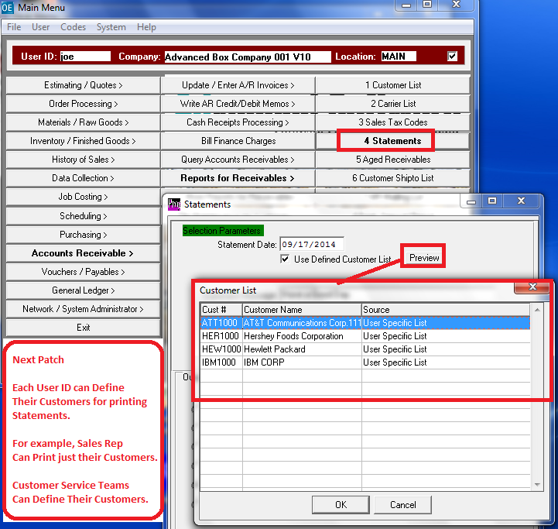

The N-K-1 CustomerList  Logical Value must = YES.

Then the VIEW form defined specific customers for ALL user IDs.

Or.

View Form will point to the customers defined by User ID.

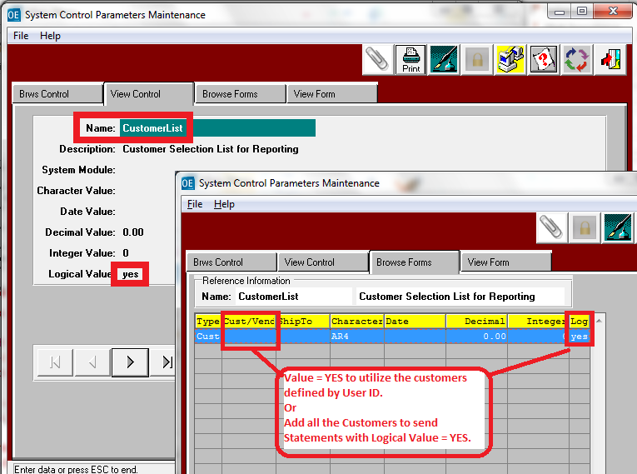

Defining Customers for Specific User ID.

1. Set N-K-1 CustomerList Logical Value = Yes
2. Set N-K-1 CustomerList View Form  Logical Value = Yes and customer Code = Blank.
3. For each User Id, click he Customers Tab and Select Customers

